Please see below for an example of the screen you should see upon logging into your GOV.UK online account.
- Please select payments.

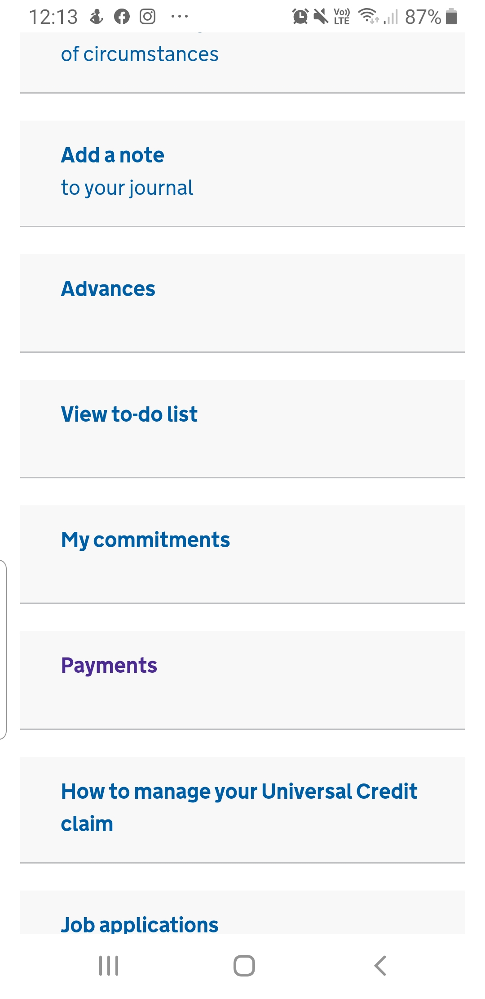
- Select the most recent statement from the list provided.

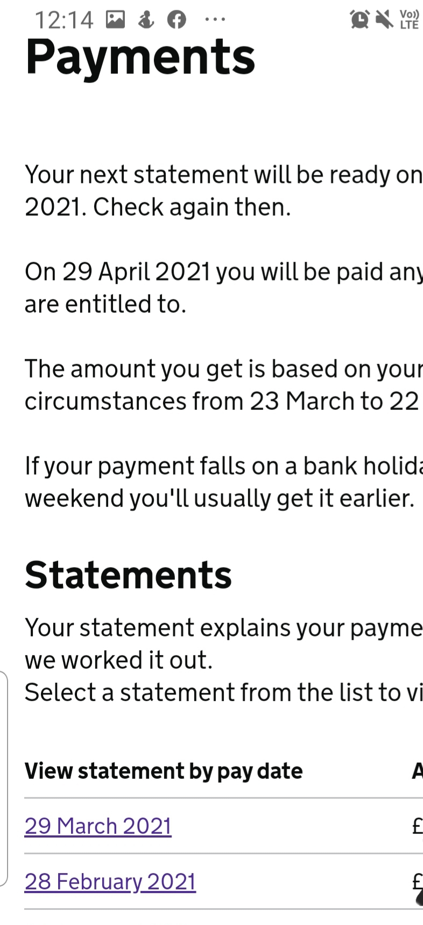

- Please select ‘Print this statement’ and download. You need to send us the full document.
