Help your customers take #TheFirstStep with StepChange
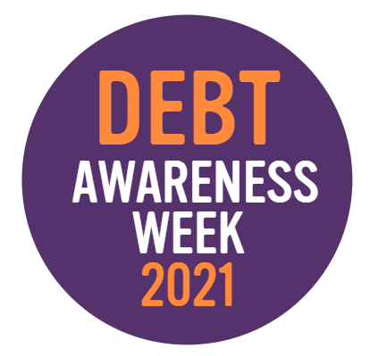
Dealing with debt can be confusing and scary for many. There are hundreds of reasons why people put off getting debt advice – some fear they’ll be judged, others bury their head in the sand and hope things will improve, and many simply aren’t aware that free, impartial debt advice is available.
StepChange Debt Charity estimates that the average person waits 12 months between realising they’re in financial trouble and getting debt advice for the first time, during which their situation can get even worse.
But… What if you could make a difference?
Debt Awareness Week is StepChange Debt Charity’s annual campaign to raise awareness of free, impartial debt advice. This year, we’re working with our partner organisations like yours to help customers to overcome their barriers to getting debt advice, and take #TheFirstStep towards resolving their money worries.
Why now?
It’s impossible to ignore the fact that the past year has been difficult for many of us. No one could have anticipated how long the coronavirus situation would last for, or how hard the financial impact would hit.
This year’s Debt Awareness Week will run from 22-28 March, marking a year since lockdown measures were first introduced, and we’ll be looking at how the pandemic has affected household finances, and how we can help customers who are struggling. With much of the government support due to come to an end soon, we’re expecting to see an increase in the number of people needing free, impartial debt help.
How can I support Debt Awareness Week?
If you’re talking to a customer facing financial difficulty, whether over the phone or via digital channels like web chat, you can help them to take #TheFirstStep by referring them to StepChange.
Whether they need debt advice, a way to get back on track after the financial effects of coronavirus, or support with budgeting or managing a persistent debt, we can help. We’ll provide free, impartial advice tailored to their individual situation either online or by telephone, and help them find a way to deal with their debts with our wide range of solutions. We never judge, and we’ll support your customer for as long as they need us.
How do I make a referral?
There are several ways you can refer a customer to us:
- Use the easy referral form - If they don’t have time right now, or need time to gather their details you can make a referral using our new easy referral form. We can arrange a call-back at a time that suits them or send them an email or SMS so they can engage with us online at their own pace. Find out more and start using the form.
- Direct them to online advice - By directing your customer to the website, they can get more information about the charity, and then engage with us when they’re ready. Our online services are available 24/7. Advise them to visit our website at www.stepchange.org
- Get the conversation started and warm transfer them to us now - if the customer has their financial details to hand and wants to get started straight away, warm transfer the call to us.
- Alternatively, customers can also call us directly for free on 0800 138 1111, Monday to Friday 8am to 8pm and Saturday 8am to 4pm. Calls are free including all mobile networks.

Thank you for supporting Debt Awareness Week 2021. Together, we can help your customers take #TheFirstStep towards dealing with their money worries.

