Worried about money? StepChange Debt Charity can help
With the cost of living on the rise, many people are worried about their household finances. Money worries can seriously affect your mental health and wellbeing, having a significant impact on your life both at home and at work.
However, if you’re struggling, help is at hand – StepChange Debt Charity can support you with money guidance, budgeting support or debt advice.
At StepChange, our team of experts helps thousands of people every week to deal with their debt problems and get their lives back on track.
Our research shows that people often wait up to a year to get help when they’re struggling financially. During this time, bills can mount up and charges can increase.
As people get more stressed, they become less able to manage their money and they get caught in a vicious cycle. We want to help colleagues understand what StepChange has to offer so they can get help fast if they ever get into financial difficulty

How do I know if I need debt advice?
There are many warning signs of a possible debt problem. If you often find yourself relying on credit to pay for essentials like food and bills, or you find yourself stuck in your overdraft month after month, these could all be signs that you’re struggling financially.
If you’re worried, we recommend you visit www.stepchange.org and use our online tool, to help us work out what kind of support is best for your unique circumstances.

How debt advice works
No matter how large or small your debt problem may be, StepChange can help. Whether you contact them online or over the phone, you’ll follow a straightforward advice process:
- They’ll help you go through your debts, income and spending to help you to create a budget
- Based on this, you'll get a personal action plan and recommended debt solutions that suit your situation
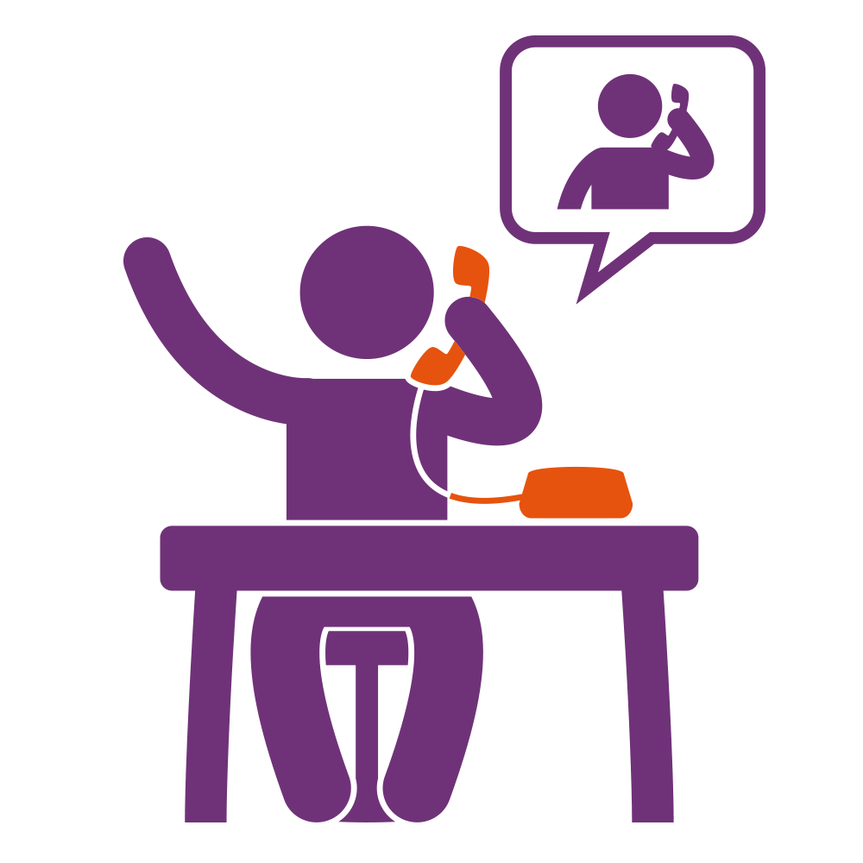
- If you want to go ahead with their recommendation, they’ll help you get things set up and give you the support to deal with your debts, however long it’s needed.

Get support today
If you think you’d benefit from specialist debt help, visit www.stepchange.org to get started and take the first step to getting your finances back on track. Alternatively, you can call 0800 138 1111 Monday-Friday, 8am-8pm or Saturday 8am-4pm.

