Digital checklist
A guide to signposting to our website and referring into online debt advice

Step 1: Add basic information

Add some simple web copy to your website about our online advice tool so your customers can get help straight away:

Who is StepChange Debt Charity?

StepChange Debt Charity is the UK’s leading debt advice charity, helping over 650,000 every year to take back control of their finances, and their lives.
The support they offer is free, impartial and confidential and every client receives expert, personalised advice to help them deal with their debts.

Visit their website for online advice at www.stepchange.org/start, or call them on 0113 138 1111 Mon-Fri 8am-8pm, Sat 8am-4pm.

Step 2: Add some extra detail
Explain the debt advice process to increase the chance that your customers will engage with us:

How does their debt advice work?

- They’ll ask for information about your finances to get a full picture of your situation. This will help to create a realistic monthly budget, to see what you can afford to pay towards your debts
- You’ll receive tailored debt advice, a personal action plan and a recommendation of the best debt solution to help you take control of your finances
- You’ll have all the information you need to make an informed decision

Step 3: Help solve problems
Enhance your content by adding links to the debt information section of our website. :

Link directly to popular debt information library articles, depending on your customer’s needs, for example:

County Court judgments: www.stepchange.org/ccj
Bailiff help and advice: www.stepchange.org/bailiffs
Dealing with credit card debt: www.stepchange.org/credit-card-debt
You can use this text to introduce it:

Our debt information section contains everything you need to know about debt, including what bills you should prioritise and how you can deal with court action or bailiffs.

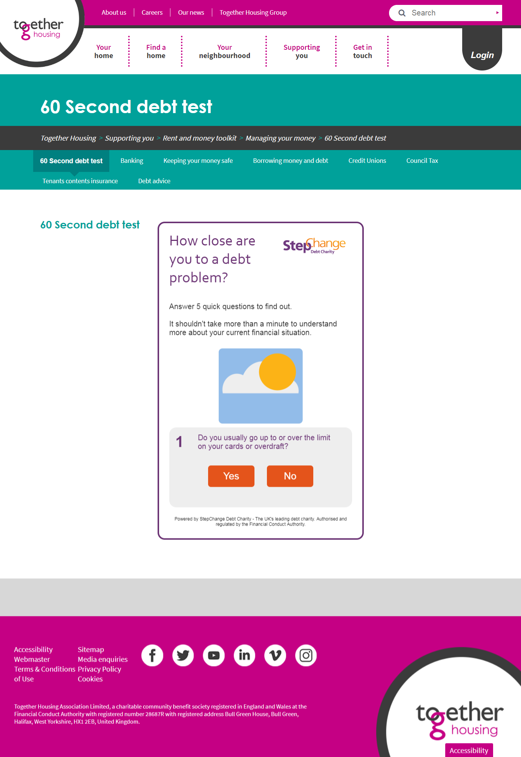
Step 4: Add the debt test
Help your customers understand whether they’ve got a debt problem:

- Easy to embed on your website and mobile friendly
- Based on our clients’ data and research by the University of Bristol
- It asks about the five most common ‘debt danger signs’ - most of our clients display at least two of these signs when they first contact us
- Performs a ‘health check’ on their situation in under a minute
- Gives your customers a clear ‘diagnosis’ and a set of next steps to ‘remedy’ their situation no matter what their situation is

See the debt test and find out how to add it to your site: www.stepchange.org/get-the-debt-test

Step 5: Support your teams
Use our training support materials, embed our digital referral form and talk about StepChange in your team briefs:

- Get to know our three-step referral process, and use our handy referral guide with your teams
- Help your customers engage with debt advice at a time that suits them by using our digital referral form, to send them a one-off message from StepChange about free debt advice
- Check out our Twitter feed and use some recent news to add to your team briefs, to help your advisors keep us top of mind

