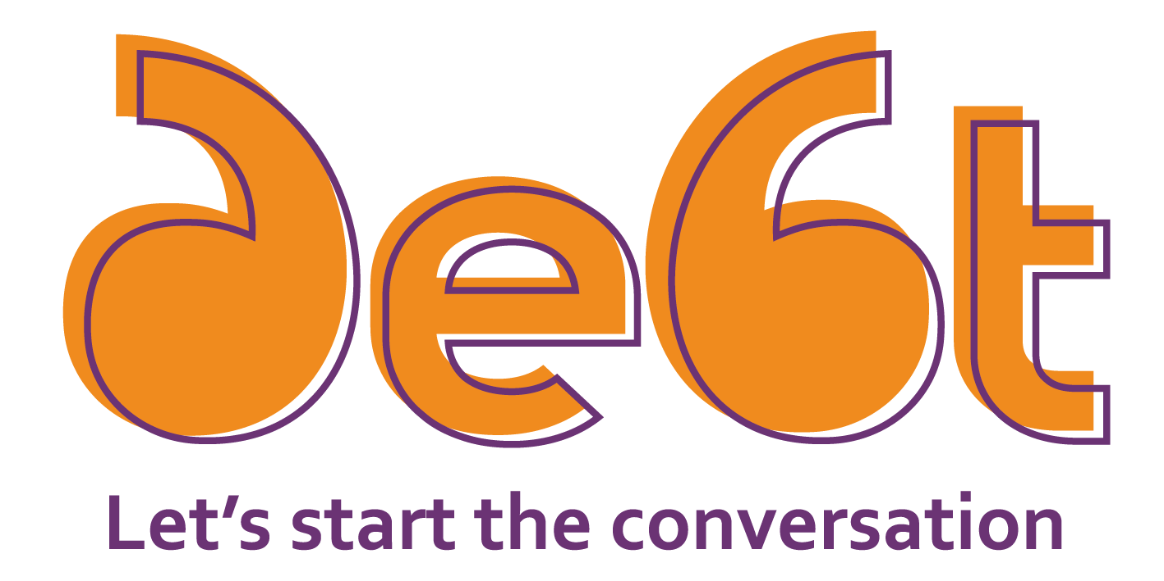

For so many, debt is a constant concern. But while people often think about it and worry about it, it’s rare that people talk openly about debt. StepChange Debt Charity’s new campaign aims to change that, igniting a national conversation about debt to help people feel less alone, and find help when they need it.

Who are StepChange Debt Charity?
StepChange is the UK’s leading provider of free, impartial debt advice and solutions. We have over 28 years of debt expertise and help hundreds of thousands of people every year to deal with their debt problems and get back on track.

What’s the campaign about?
The pandemic has dealt a financial blow to many people across the UK, with many who were previously coping now pushed into financial difficulty, while those who were previously struggling are finding it even more difficult to stay afloat. With the end of furlough and other support measures, we expect to see even more people needing debt advice.

However, our research shows that shame and stigma are key reasons why people don’t reach out for debt help when they need it. Throughout autumn and winter we’ll be igniting the conversation about debt and encouraging others to join in, aiming to normalise talking openly about debt and help people understand that free, non-judgemental support is available.

How can I support the campaign?
Look out for our campaign activity on Facebook, LinkedIn and Twitter over the coming months and share our posts to encourage more people to join the conversation. The more people we can reach, the more awareness we can raise that debt doesn’t have to be a taboo, and that having open, honest conversations about debt can really help.
If you’re talking to a customer facing financial difficulty, whether over the phone or via digital channels like web chat, you can help them by referring them to StepChange.
Whether they need full debt advice, or support with budgeting or managing a persistent debt, we can help. We’ll provide free, impartial advice tailored to their individual situation either online or by telephone, and help them find a way to deal with their debts with our wide range of solutions. We never judge, and we’ll support your customer for as long as they need us.

How do I make a referral to StepChange?
There are several ways you can refer a customer to us:
- Use the easy referral form - If they don’t have time right now, or need time to gather their details you can make a referral using our new easy referral form. We can arrange a call-back at a time that suits them or send them an email or SMS so they can engage with us online at their own pace. Find out more and start using the form.
- Direct them to online advice - By directing your customer to the website, they can get more information about the charity, and then engage with us when they’re ready. Our online services are available 24/7. Advise them to visit our website at www.stepchange.org
- Get the conversation started and warm transfer them to us now - if the customer has their financial details to hand and wants to get started straight away, warm transfer the call to us.
- Alternatively, customers can also call us directly for free on 0800 138 1111, Monday to Friday 8am to 8pm and Saturday 8am to 4pm. Calls are free including all mobile networks.

Thank you for supporting StepChange Debt Charity and joining the conversation about debt.

